From Functional Molecules to Structural Beauties
by the group of Marcel Mayor at the Department of Chemistry of the University of Basel (Switzerland) and the Institute of Nanotechnology (INT) of the Karlsruhe Institute of Technology (KIT, Germany).

Molecules are the smallest building blocks still providing the structural diversity enabling the integration of particular functions. Our target structures are often inspired by macroscopic models and working principles from various fields and for their assembly we profit from the achievements in synthetic chemistry. While in many cases the target structures are tailor-made to act as functional unit in a particular experimental set-up, there are also examples that are to a large extent motivated by their intrinsic structural beauty.
Profiting from the interdisciplinary environment of an institute of nanotechnology, the first scientific achievements were in single molecule transport experiments. Still today, a considerable fraction of the activities are geared towards integrating molecular devices as functional units in electronic circuits and belong thus to the scientific topic “molecular electronics”. Examples are the recent development of a massive parallel and CMOS compatible integration strategy for self-assembled monolayers,^{[1]} a series of biphenyl derivatives with fixed inter-phenyl torsion angles enabling to corroborate the single molecule character of the transport studies,^{[2-4]} a single-molecule electroluminescence experiment complementing the physical response of the molecular junction,^{[5]} or E-filed triggered single molecule switches.^{[6-8]}
An example of more structural beauty and fundamental physical properties driven research direction are the helical chiral “Geländer”-type structures that were developed in the past few years in our lab. While the initial molecular design comprised benzylic ethers as elongated and wrapping oligomer sub-strand,^{[9,10]} we recently reported the first all-carbon based “Geländer” structure.^{[11]} However, even though not obvious from the beginning, also these activities are motivated by envisaged transport studies with magnetic field dependent molecular junctions as long-term objective. Recently a first molecular design profiting from 1,3-diethinyl interlinked phenyl subunits as conjugated banister was proposed^{[12]} and first loop-shaped molecular architectures will be presented.
Supramolecular concepts were applied to control and pre-organize the spatial arrangement of molecular building blocks. Examples are water soluble rotaxanes^{[13]} and daisy chains,^{[14]} chiral metal complexes,^{[15]} molecular graph paper based on current sensitive self-assembled monolayers,^{[16]} or the production of molecular textile by pre-organizing the monomers in a MOF layer.^{[17]}
Our current interests are geared towards chiral model compounds and their interplay with external electric or magnetic fields, controlled und unidirectional motion in molecular machines, and new (super)molecules of unique symmetries.

[1] G. Puebla-Hellmann et al. Nature, 2018, 559, 232-235. [2] D. Vonlanthen et al. Angew. Chem. Int. Ed. 2009, 48, 8886-8890. [3] A. Mishchenko et al. Nano Lett. 2010, 10, 156-163. [4] A. Mischenko et al. J. Am. Chem. Soc. 2011, 133, 184-187. [5] C. W. Marquardt et al. Nature Nanotech. 2010, 5, 863-867. [6] G. D. Harzmann et al. Angew. Chem. Int. Ed. 2015, 54, 13425-13430. [7] L. Gerhard et al. Nature Commun. 2017, 8, 14672. [8] L. Le Pleux et al. Eur. J. Org. Chem. 2017, 22, 3165-3178. [9] M. Rickhaus et al. Angew. Chem. Int. Ed. 2014, 53, 14587-14591. [10] M. Rickhaus et al. Chem. Eur. J. 2015, 21, 18156-18167. [11] R. Mannancherry et al. Chem. Sci. 2018, 9, 5758-5766. [12] L. Bannwart et al. Eur. J. Org. Chem. 2018, 3391-3402. [13] Y. Aeschi et al. Eur. J. Org. Chem. 2017, 4091-4103. [14] Y. Aeschi et al. Chem. Eur. J. 2018, doi.org/10.1002/chem.201803944. [15] T. Brandl et al. Chem. Sci. 2018, 9, 3837-3843. [16] M. Lindner et al. Angew. Chem. Int. Ed. 2017, 56, 8290-8294. [17] Z. Wang et al. Nature Commun. 2017, 8, 14442.

Short CV

Marcel Mayor received his PhD (1995) from the University of Bern (Switzerland) supervised by Professor Rolf Scheffold and Professor Lorenz Walder. After working with Professor Jean-Marie Lehn at the University Louis Pasteur in Strasbourg (France) and at the Collège de France in Paris, he founded his own research group at the Institute of Nanotechnology (INT) of the Forschungszentrum Karlsruhe GmbH (today Karlsruhe Institute of Technology, KIT, Germany) in 1998. On defending his habilitation in 2002, he became associtae Professor of Chemistry at the University of Basel in 2004, where he was promoted to full Professor in 2011. His current research interests are supramolecular chemistry, molecular electronics, nanoscale architectures, functional materials and hybrid materials.

Pictures:

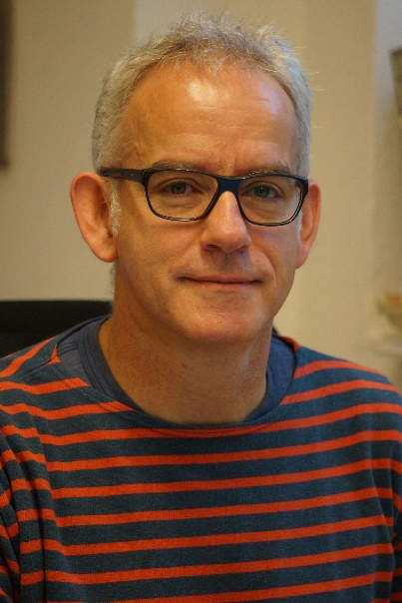
Portrait

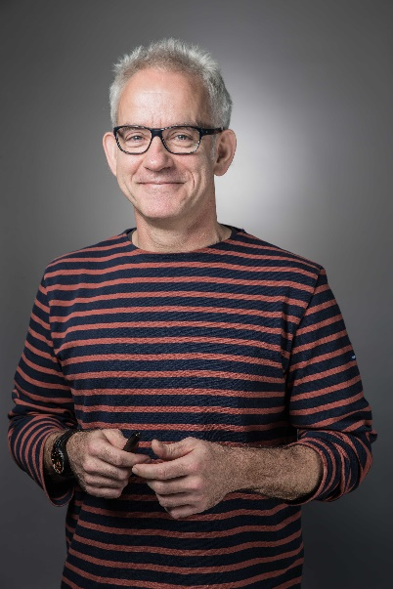
Upper part

