Titel Arial 14 Pt All Words Upper Case
Presenting Author, Corresponding Author*, Other Authors (Arial 11 Pt)

Affiliations (institution, university, street, postcode, city, country) Arial 11 Pt
E-mail: Corresponding Author (Arial Italic 11 Pt)

Main Text, Arial 12 Pt, Standard, first line of each paragraph with indentation. Reference numbers as standard text in square brackets after punctuation.[1] Main Text, Arial 12 Pt, Standard, first line of each paragraph with indentation. Reference numbers as standard text in square brackets after punctuation.[2] Main Text, Arial 12 Pt, Standard, first line of each paragraph with indentation. Reference numbers as standard text in square brackets after punctuation. Main Text, Arial 12 Pt, Standard, first line of each paragraph with indentation. Reference numbers as standard text in square brackets after punctuation.
Main Text, Arial 12 Pt, Standard, first line of each paragraph with indentation. Reference numbers as standard text in square brackets after punctuation. Main Text, Arial 12 Pt, Standard, first line of each paragraph with indentation. Reference numbers as standard text in square brackets after punctuation. Main Text, Arial 12 Pt, Standard, first line of each paragraph with indentation. Reference numbers as standard text in square brackets after punctuation.
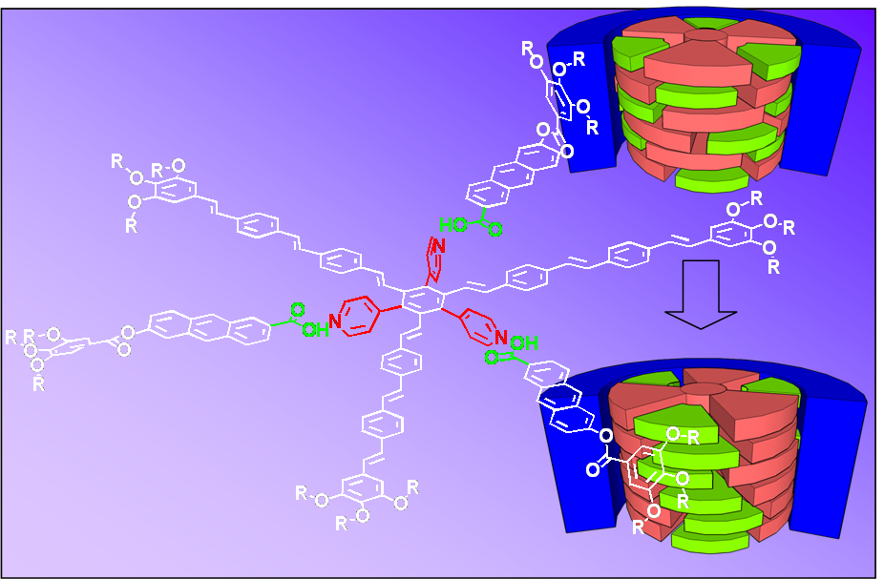

Figure Caption Arial 10 Pt

References: (Arial Bolt 10 Pt)
- A. (Initials) Author 1 (Last Name), A. Author, Journal Name Italic Year Bolt, Volume Italic, Page-Page. Arial 10 Pt
- A. (Initials) Author 1 (Last Name), A. Author, Journal Name Italic Year Bolt, Volume Italic, Page-Page. Arial 10 Pt
- A. (Initials) Author 1 (Last Name), A. Author, Journal Name Italic Year Bolt, Volume Italic, Page-Page. Arial 10 Pt

